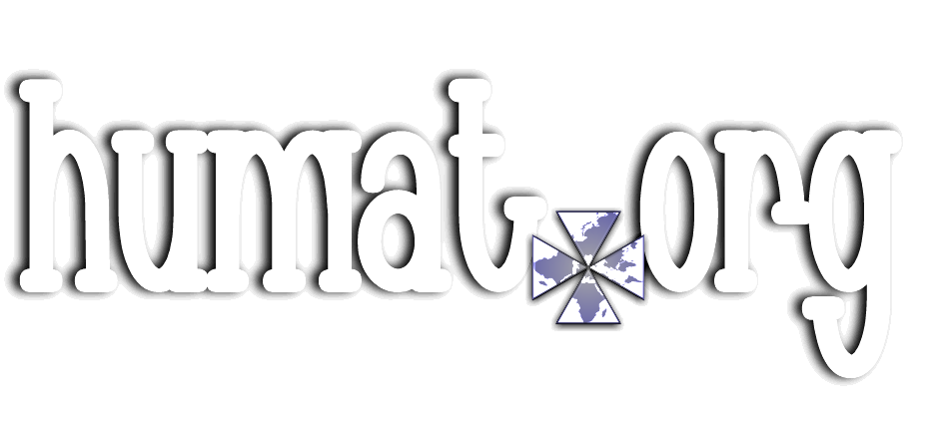

**Thank you for registering with .**

**You have now joined a network of humanitarians, connected to make the world a better place.**

**Please confirm your registration**

**by clicking this link:**

**link…httm://confirmhumatreg…**

**Pop-up Confirmation**



**Welcome (username).**

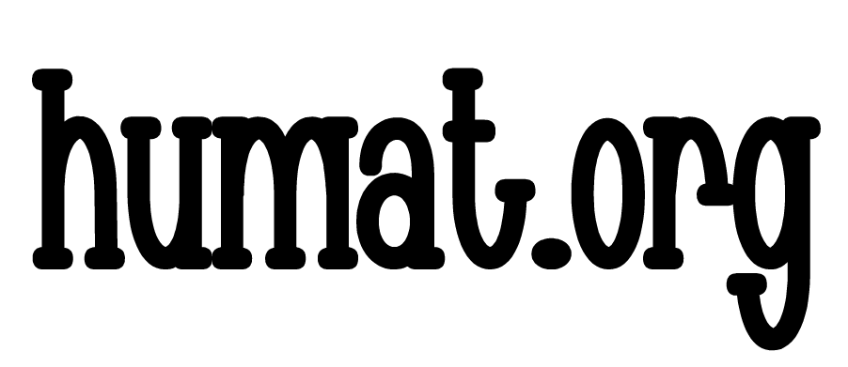**You are now registered with**

**.**

